

Project Interim Report

On

File Compression Simulator (Using Core Java & OOP Concepts)
RU-100-01-00012
Object Oriented Programming with Java

SESSION: 2025-26

Submitted By – Prashant Patel
Erp no - 10995

Bachelor of Technology in Computer Science & Engineering Core association with Google

Under the Guidance of Mr. Ashish Shivhare Java Expert

SCHOOL OF COMPUTER SCIENCE AND ENGINEERING RUNGTA INTERNATIONAL SKILLS UNIVERSITY
BHILAI, CG

(April 2026)

Abstract
Short summary about your project in 150-200 words. Include the following
- What is your project ..

- This project is a Banking Account System developed in Java that simulates basic banking operations in a simple and efficient way. It is designed to manage customer accounts and perform essential transactions such as deposits, withdrawals, and balance inquiries. The system uses object-oriented programming concepts like classes, objects, inheritance, and encapsulation to ensure clean structure and scalability
- Why is it needed

- This project is needed because managing financial transactions manually can be time-consuming and error-prone. A digital system helps automate these processes, improves accuracy, and provides a faster way to handle banking operations. It also serves as a foundational model for understanding how real-world banking software works.
- What it does
The system allows users to create accounts, store customer details, and securely manage funds. It can validate transactions, prevent overdrawing (if implemented), and maintain records of account balances. Overall, this project demonstrates how Java can be used to build reliable and user-friendly financial applications while reinforcing core programming skills.

Introduction
Same information about your project but in details you can also add some of the features of your project Objectives ( what your project does )
- Manage book records
- Track issued books
- Reduce manual work
- Apply OOP concepts

Scope
This project is suitable for small libraries and can be extended with database integration in future.

System Requirements
Hardware: Computer with 4GB RAM
Software: Java JDK, IDE (VS Code/Eclipse/Edit Plus)

Methodology
Explain how your project works like first we add something, then search, then modify etc.

Flowchart
Includes Flowchart ( Start, Menu, Choice, Operations ) , and Class Diagram representing system structure. Sample class diagram –
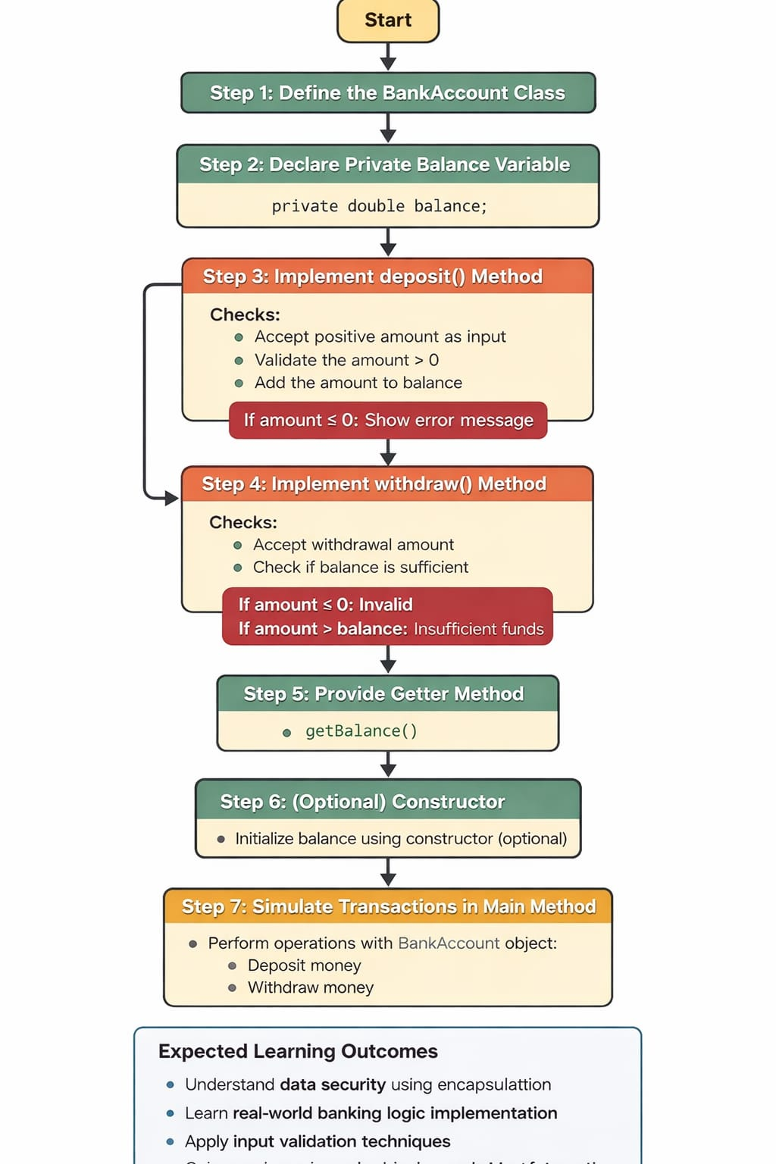

ClassName
- Variables inside class
- Methods inside class
- If array is present within the class also mention it here

Implementation

The banking system is implemented using a class named BankAccount. It contains a private variable balance to store the account amount securely (encapsulation). A deposit() method is created to add money, where it first checks if the amount is positive before updating the balance. A withdraw() method is used to deduct money, ensuring the amount is valid and that sufficient balance is available. A getBalance() method returns the current balance without allowing direct modification. Optionally, a constructor initializes the balance when the object is created. In the main method, objects of the BankAccount class are created, and operations like deposit and withdrawal are performed. Finally, the updated balance is displayed, simulating real-world banking transactions in a simple way

Gantt Chart
- Planning & Structure
A Gantt chart helps you break the project into tasks (design, coding, testing, etc.) and set timelines. Even if it's already built once, rebuilding or modifying still needs planning.

Time Management
It shows:
When each task starts When it should finish
This helps avoid delays and last-minute panic.

Conclusion
The project successfully demonstrates Java OOP concepts and provides a functional system.

References Book Format:
[1] Author(s), *Book Title*, Edition. City: Publisher, Year.

Example:
[1] H. Schildt, *Java: The Complete Reference*, 11th ed. New York: McGraw-Hill, 2018.

Website Format:
[2] Author (if any), "Title of page," Website Name. [Online]. Available: URL

Example:
[2] Oracle, "Java Documentation," Oracle. [Online]. Available: https://docs.oracle.com

Conference Paper
Format:
[3] Author(s), "Paper title," in Proc. Conference Name, year, pp.
Example:
[3] S. Kumar, "AI in Education," in Proc. IEEE Conf. on AI, 2021, pp. 120-125.

Journal Article
Format:
[4] Author(s), "Title of paper," Journal Name, vol., no., pp., year.
Example:
[4] A. Sharma and R. Gupta, "Machine Learning Techniques," International Journal of AI, vol. 5,
no. 2, pp. 45-50, 2020.

